**GCP Lec 25** :- GCP VPC Network

* In AWS also it is called VPC, In Azure it is called Virtual Network.

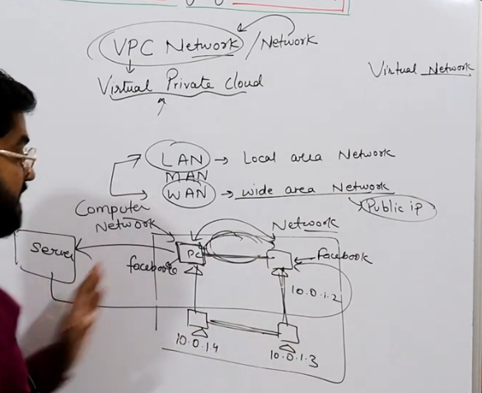

# Connection of two or more Networks is known as a Computer Network. In a **LAN**, all the systems are connected through **Private IP** & in a WAN, all the systems are connected through Public IP or Internet.

# A LAN in the Cloud Ecosystem is known as Virtual Private Cloud Network.

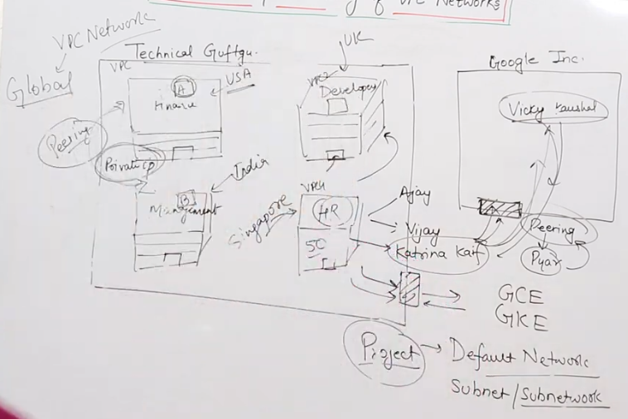

# Basics of VPC : We will create all Google Cloud Services such as GCE (Google Compute Engine), GKE (Google Kubernetes Engine) etc inside a VPC Network.

Whenever we create a Project, a default VPC Network gets automatically created and inside that default VPC Network we get a subnet (sub network) in every region. Now, whenever we create a Virtual Machine, it by-default gets created inside the subnet.

Now, we need to create our own Network & create our servers inside that network.

What does a VPC Network do?

* In GCP, the VPC Network is a global service. In AWS & Azure, it is a regional service.

What do we mean by global & regional service?

In AWS & Azure, multiple servers in a region can be under the same network. So In AWS & Azure, the VPC Network is a regional service. So, we have to do peering to connect one VPC Network of a regional to another using a **Private IP**. Eg: Peering is done to connect one VPC Network of USA to a VPC Network of India using a **Private IP**. Peering through **Private IP** is possible as all the regions in the whole world are connected through cables with every data center. Thus, this acts as a very big Local Area Network (LAN). This is why Cloud is considered as very secure.